**CAP 276: DATA COMMUNICATION AND NETWORKING LABORATORY**

**CONTINUOUS ASSESSMENTS (C.A)-3**

**ST_NAME: - EKHLAKH AHMAD**

**REG NO.: - 12209166**

**ROLL NO.: - RD2215B67**

**SECTION: - D2215**

**GROUP: - 2**

**Q.1. Connect two or more networks with a router in each network and configure the routers for static routing.**

**Process: -**

* Open Cisco packet tracer.
* Select PC
* Draw three PC the blank area.
* Select Switch “PT-switch”.
* Draw two switches.
* Select Wired.
* Connect PC to Switch with wired.
* Again, repeat same process on right side.
* Select router.
* Draw two router blank area.
* Connect two routers with two Switch respectively.
* Click on PC.
* Then a dialog box will be open.
* Click on Desktop Tab.
* Click on IP Configuration.

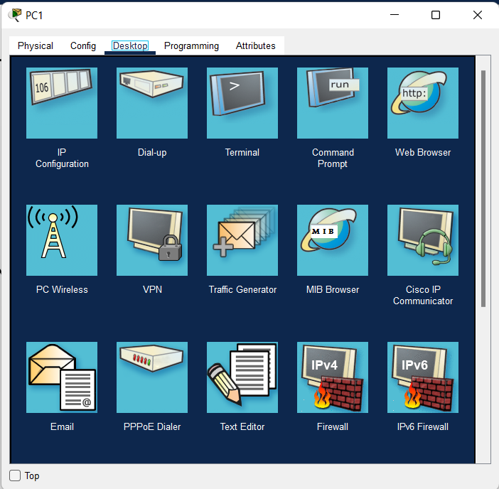

* Check Static radio button.
* Click on IPv4 and enter IP address
* Press Enter key.
* Again, click on Router-PT and draw two routers.
* And assign IP Address both of two.
* Again, click on first router and click on Config.
* Click on FastEthernet 0/0 and assign IP address.
* Again, click on second router and click on Config.
* Click on FastEthernet 1/0 and assign IP address.

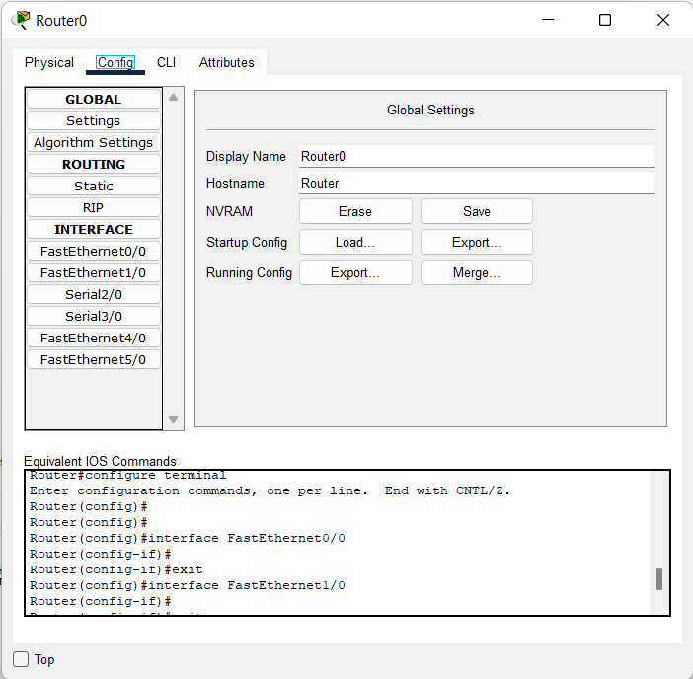

* Click on first router and click on Config and click on Static.
* 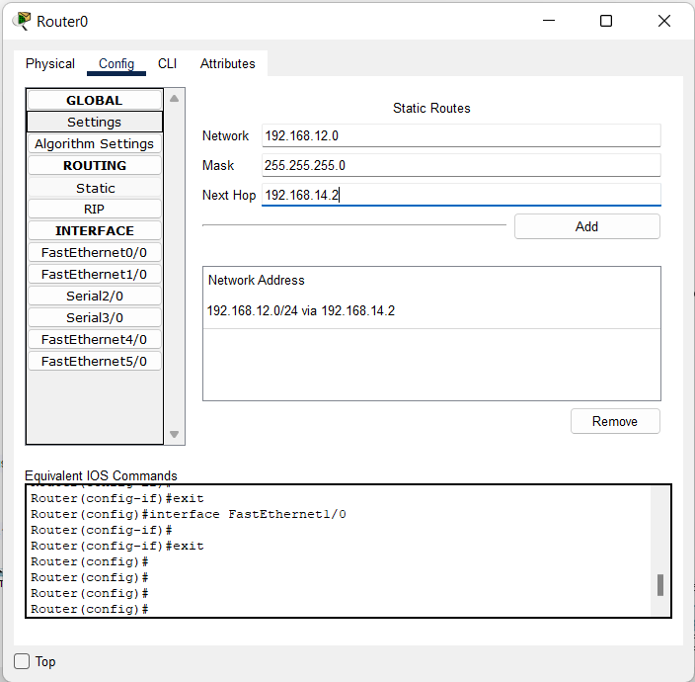Assign Network ID, Mask ID and Next Hop.

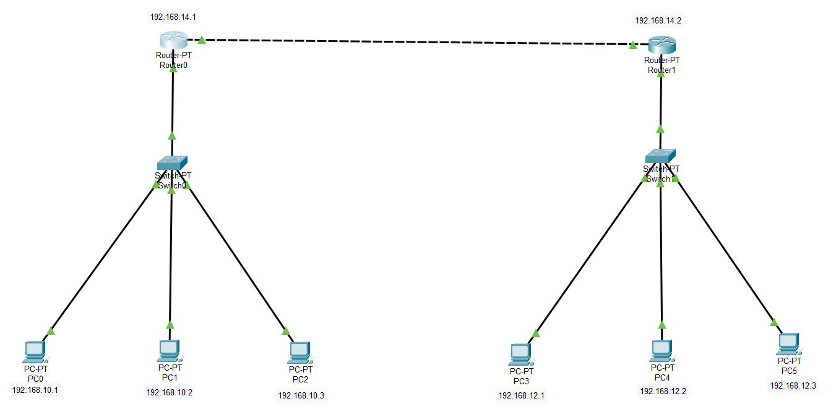

**Q.2. Design a network with hybrid topology that include a bus backbone and three Star network, check the connectivity using ping command, sending PDU in real time mode and simulation mode.**

